**ET4132 Final Project Report**

17184614 Luke O’Sullivan Griffin & 17212359 Mike Vriesema

**Introduction & Brief Rationale:**

We chose the concept of a programming pal hire/teaching system as the fundamental base for our company. The reasoning behind this choice is it is something we are both interested in and would hypothetically be a very useful service to struggling computer science students. The company would provide services to allow you to hire a programmer in a particular language at a set rate to design an application or hire a programmer to assist in the teaching and learning of new skills in a chosen programming language or from scratch.

**Database Modelling & Design**

The **modelling** and **design** steps of your database, using appropriate illustrations, such as E-R diagrams. [INSERT PHPMYADMIN SCREENSHOTS AND DRAFT EXCEL DATABASE HERE]

**Database Implementation: SQL**

Implementation of the database using MySQL. [DISCUSS AND REFERENCE WEB FORMS AND SQL COMMANDS]

**Website Design & Development: HTML/CSS**

We decided to go for a simple design approach with minimalistic colours (shades of grey, white and blue).

The header consists of a h1 heading and a subscript for smaller text.

The nav bar is located underneath with customised links to each webpage.

The main body is split into two divs (content and content 2), allowing to easily place content on either side of the page. The divs are identified in the stylesheet using ID’s and Classes where appropriate.

A footer [1.1] is included which includes the address, a mailto link and links to other pages (for ease of access).

Two stylesheets were created: indexStyle.css and formStyle.css. indexStyle is used as the main stylesheet. We decided to create a second one for pages with forms as it reduced clutter and made it far easier to adjust certain elements without affecting other pages without forms.

The lessons database information is returned into a table (using echo in php) it is then formatted with CSS and displayed to the end user [1.2].

Index.php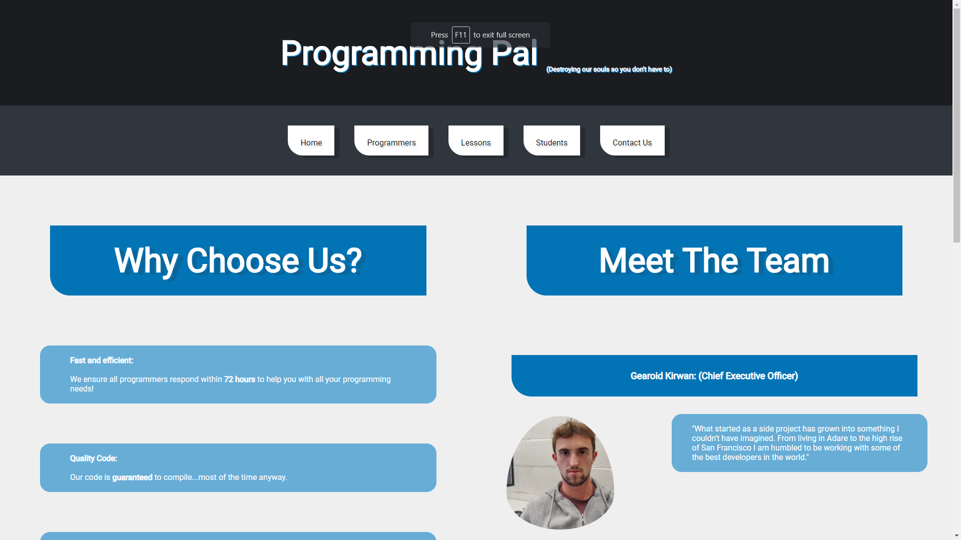

Form.php

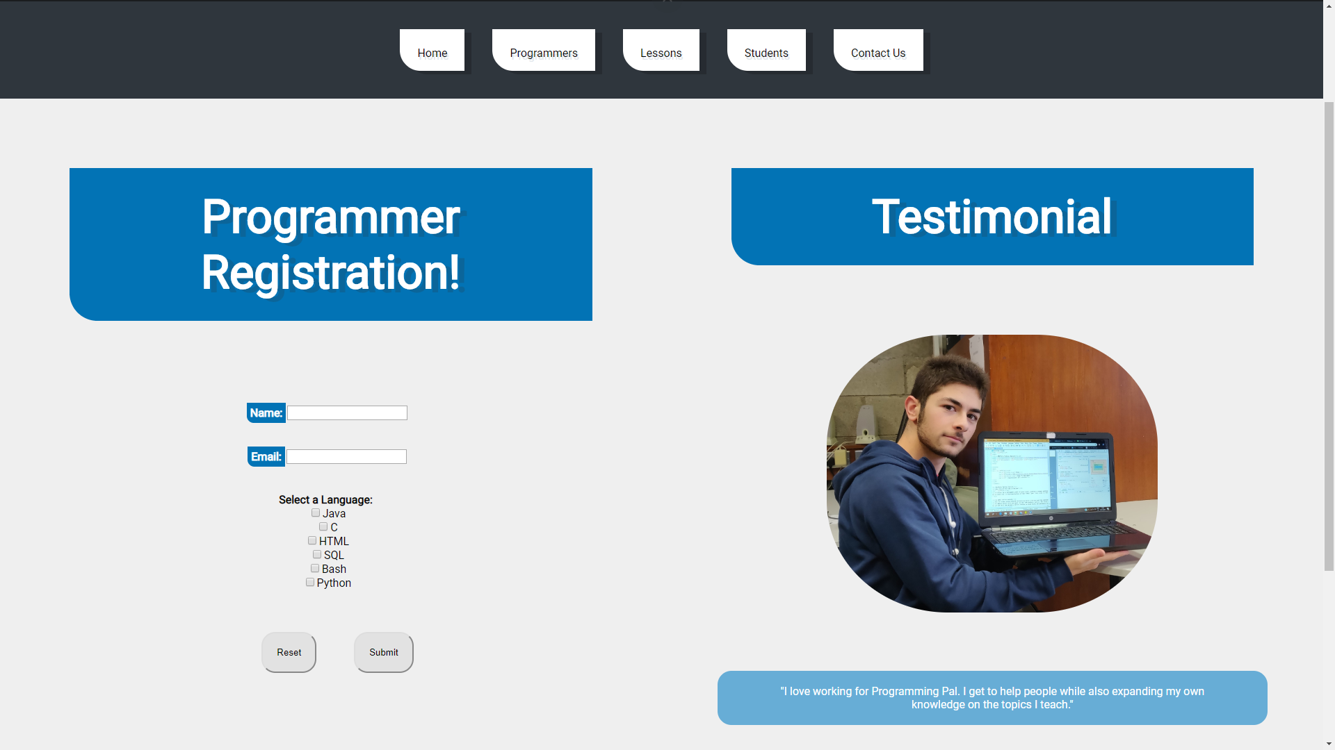

Lessons.php

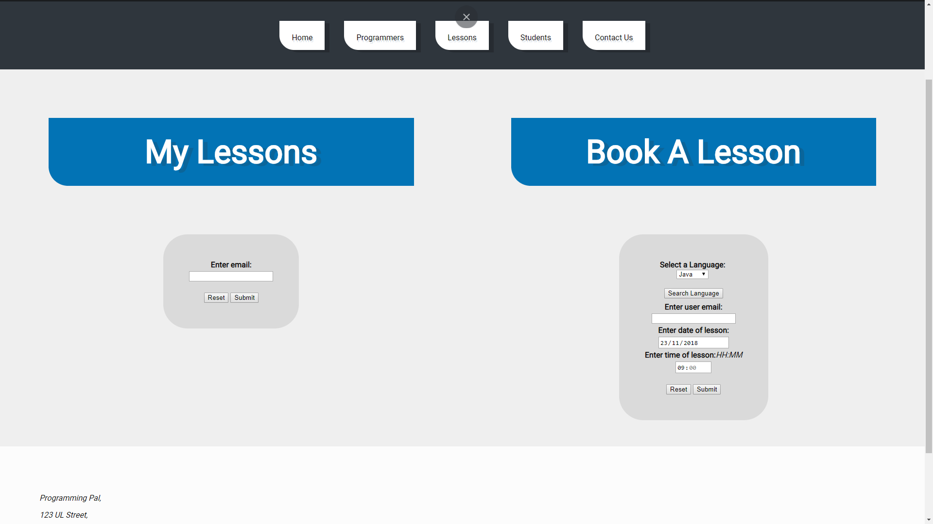

Contact.php

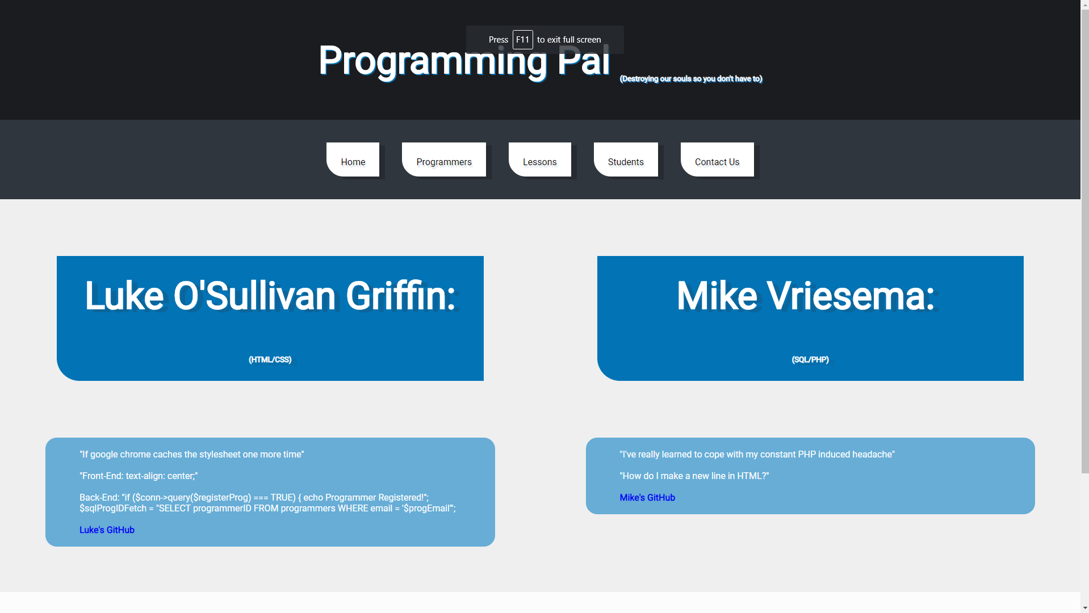

Footer [1.1] 

Lessons Table [1.2]

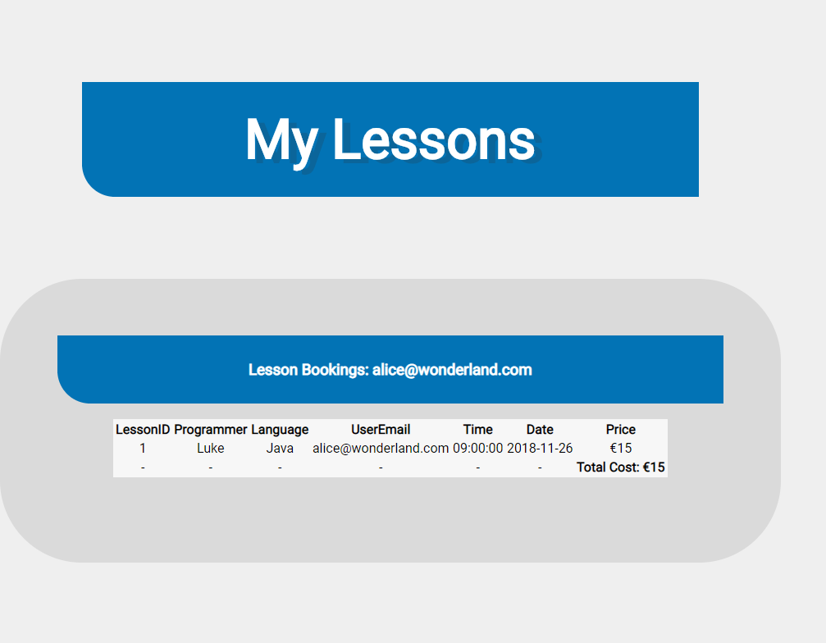

Book a Lesson [1.3]

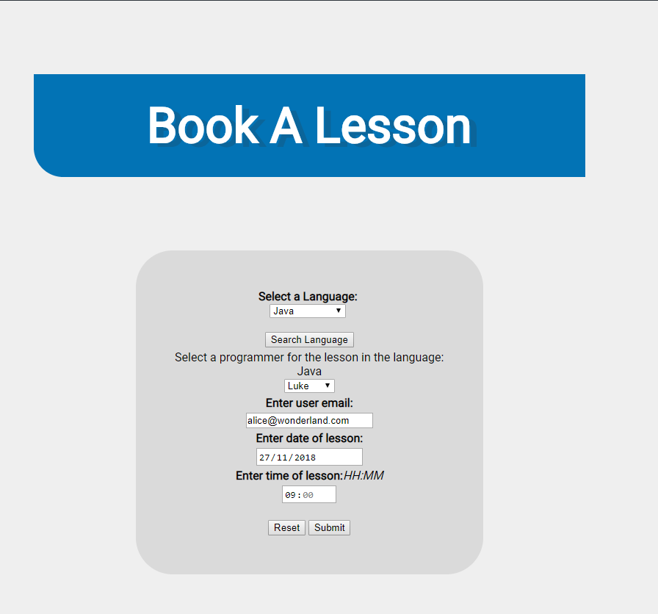

**Website & Database Connection: PHP**

Creation of appropriate **.php** files for connecting and communicating with the database - provide the code for the **.php** files you created. [EXPLAIN THE PHP CONNECTIONS]

**Results**

Discussion of results (including whether the system achieved is fully operational, problems encountered/aspects of the system that were not achieved and why).

**Conclusions**

Conclusions: why would your database design be useful for chosen business?

**Submit your work in a properly structured technical report (***one report is required from each group to be handed in during the lab on the Report Due Date above***) providing descriptions of: [ALL INCLUDED ABOVE]**